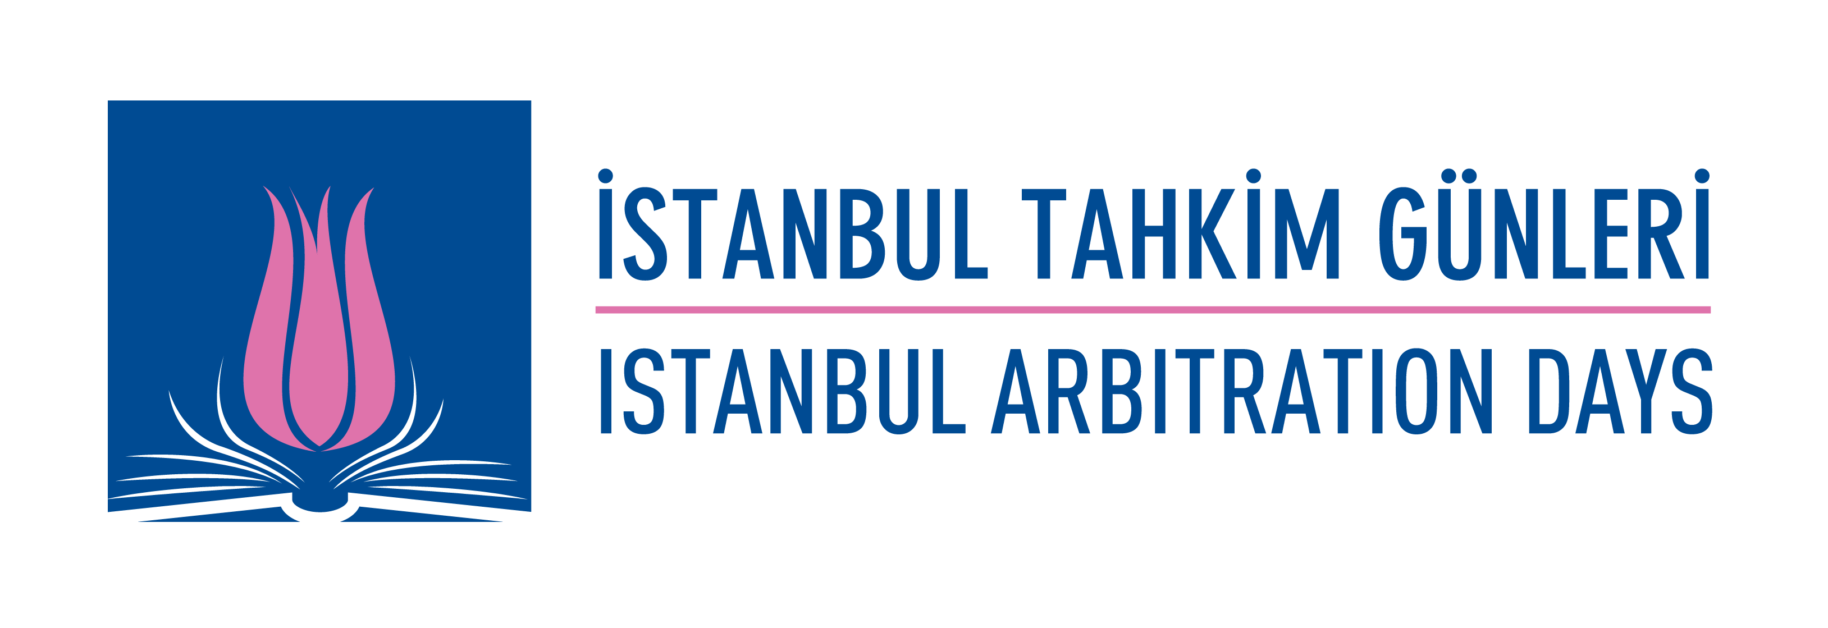

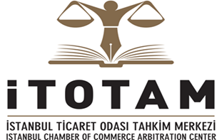 | 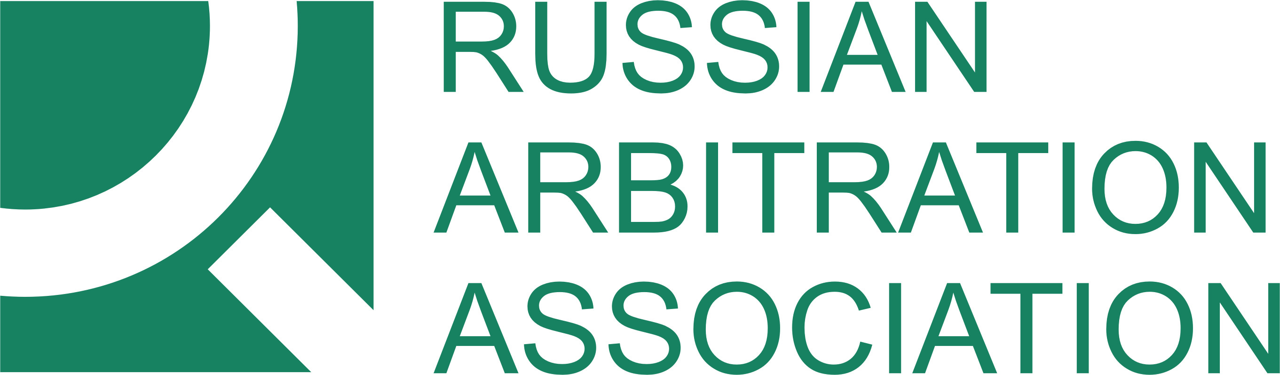 | 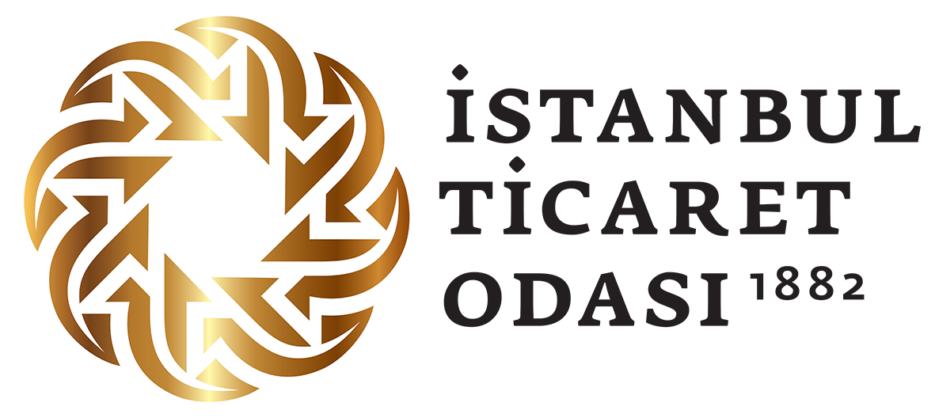

ITOTAM
ISTANBUL ARBITRATION DAYS
CONTEMPORARY TOPICS IN
AND
FUTURE OF ARBITRATION

17 NOVEMBER 2017, ISTANBUL

Meclis Salonu, İstanbul Ticaret Odası
Reşadiye Cad. 34112 Eminönü, İstanbul

ITOTAM
ISTANBUL ARBITRATION DAYS
CONTEMPORARY TOPICS IN
AND
FUTURE OF ARBITRATION

17 NOVEMBER 2017

09.00 – 09.20 Registration

09.20 – 09.40 Protocol and Opening Speeches

- Session: Arbitration in Turkey and Russia

09.40 – 10.00 “Arbitration in Turkey”
Dr. İsmail Esin, Founder and Managing Partner at Esin Attorney Partnership

10.00 – 10.20 “New Russian Legislation”
Vladimir Khvalei, RAA Chairman of the Board, Partner at Baker&McKenzie

10.20 – 10.40 “Recognition and Enforcement of Arbitral Awards in Turkey”
Prof. Dr. Ercüment Erdem, Founder and Senior Partner at Erdem&Erdem Law Firm

10.40 – 11.00 “Recognition and Enforcement of Arbitral Awards in Russia”
Roman Zykov , RAA Secretary General, Partner at Mansors

11.00 – 11.20 Q&A Session

11.20 – 11.40 Coffee Break

- Session: Contemporary Topics in Arbitration

11.40 – 12.00 “Arbitrating Construction Disputes”
Doğan Gültutan, Associate at Esin Attorney Partnership/Baker & McKenzie London

12.00 – 12.20 “Resolving Corporate Disputes in Russia”
Dmitry Dyakin, Partner at EPAM

12.20 –12.40 “Impact of Sanctions on Dispute Resolution”
Mikhail Samoylov, Senior Associate at EPAM

12.40 – 13.00 “Third Party Financing”
Wieger Wielinga, Managing Partner at Omni Broadway

13.00 – 13.20 Q&A Session

13.20 – 14.20 Lunch

3. Session: Future of Dispute Resolution

14.20 – 14.40 “Online Dispute Resolution”
Simel Sarıalioğlu, Senior Associate, Paksoy Hukuk

14.40 – 15.00 “Rules of Ethics for Counsel in Arbitration”
Timur Aitkulov, RAA Board Member, Partner at Clifford Chance

15.00 – 15.20 “Transparency in Arbitration – Do we need it?”
Aslı Budak, Partner, Partner at Hergüner Bilgen Özeke

15.20 – 15.40 “Avoiding Disputes Through Smart Contract”
Ass. Prof. Dr. Özgün Çelebi, Koç University Faculty of Law

15.40 – 16.00 Q&A

16.00 – 16.20 Coffee Break

16.20 – 17.00 ITOTAM-RAA Signing Ceremony of the ITOTAM – RAA Cooperation Agreement

